**Objective:**

To operate the cycling/roving of a car’s wheel for a desired designed circuit.

**Instrument Required:**

1. PIC16F873
2. Motor (2)
3. Switch (3)
4. LED (3)

**Circuit Diagram:**

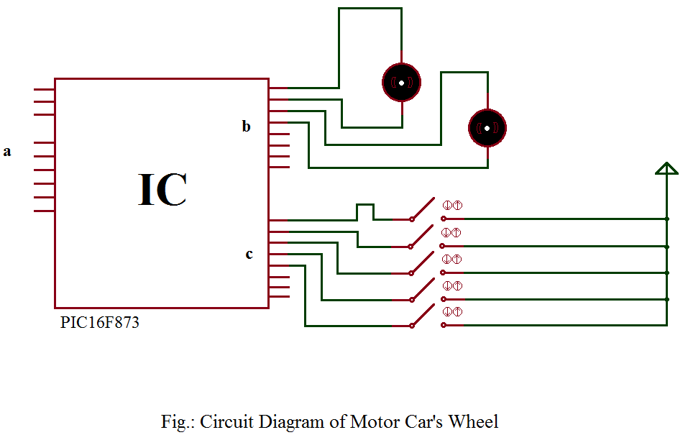

**Source Code:**

void main()

{

trisb=00000000;

portb=00000000;

trisc=00011111;

portc=00000000;

while(1)

{

if(portc==0b00000001)

{

portb=0b00000101;

}

if(portc==0b00000010)

{

portb=0b00001010;

}

if(portc==0b00000100)

{

portb=0b00000110;

}

if(portc==0b00001000)

{

portb=0b00001001;

}

if(portc==0b00010000)

{

portb=0b00000000;

}

}

}

**Schematic Diagram:**

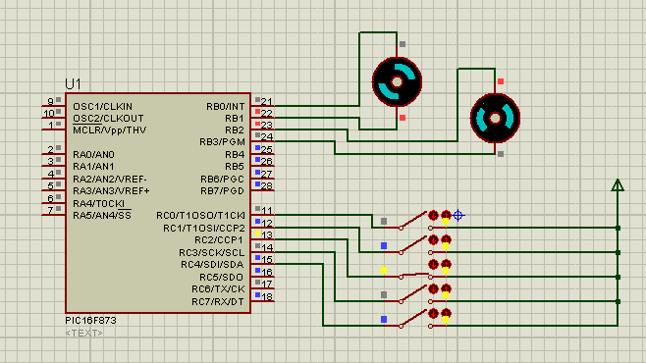

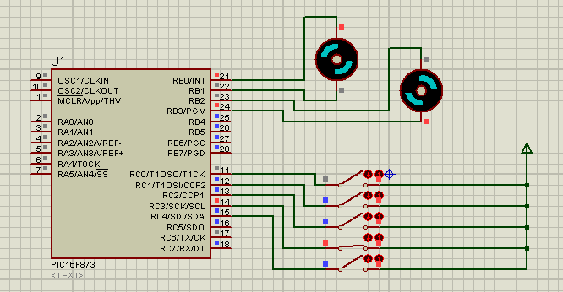

**Conclusion:**

To design the circuit above we have used the Proteus 7 Professional & to operate the circuit diagram, we have created programming code using mikroC Pro. In the end, we have operated the roving of a car’s wheel in several ways for the desired circuit above.